 |  | 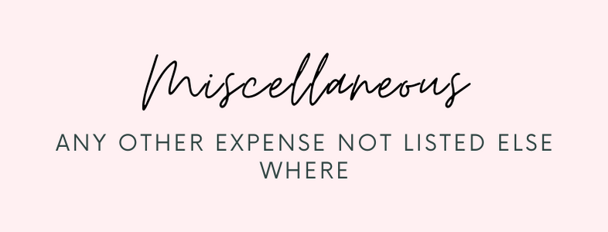 |  |  |  | emily franks  independent sales director  5665 lower 182nd st west  farmington minnesota  55024
 |  | 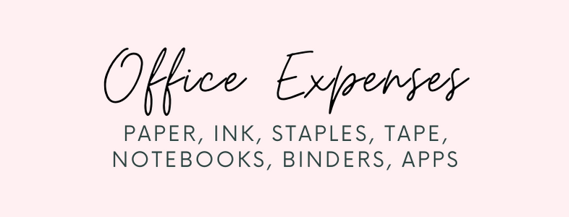 |  |  |  | emily franks  independent sales director  5665 lower 182nd st west  farmington minnesota  55024
 |  |  |  |  |  | emily franks  independent sales director  5665 lower 182nd st west  farmington minnesota  55024
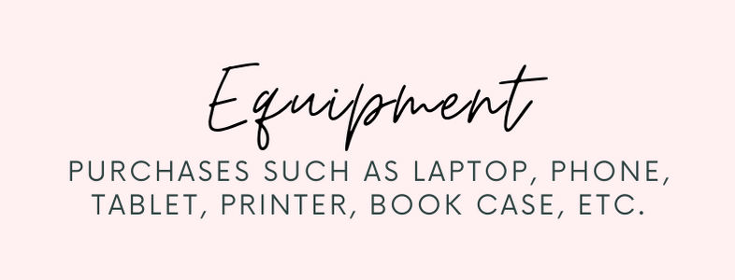 |  | 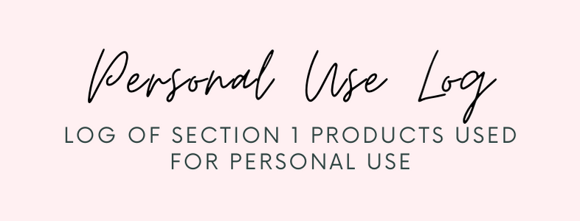 |  |  |  | emily franks  independent sales director  5665 lower 182nd st west  farmington minnesota  55024
 |  | 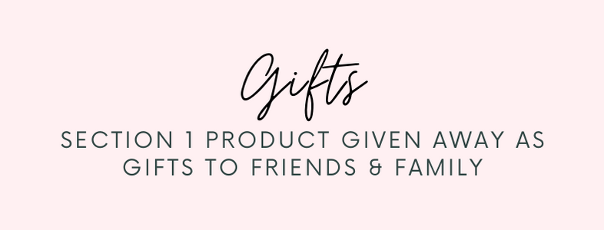 |  |  |  | emily franks  independent sales director  5665 lower 182nd st west  farmington minnesota  55024
 |  |  |  |  |  | emily franks  independent sales director  5665 lower 182nd st west  farmington minnesota  55024
 |  | 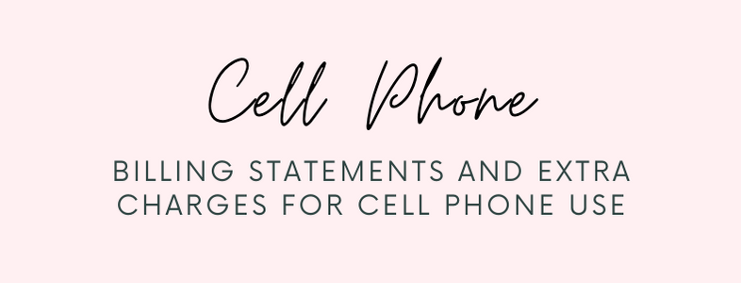 |  |  |  | emily franks Emily Franks  Independent Sales Director  5665 Lower 182nd St West  Farmington Minnesota  55024  independent sales director  5665 lower 182nd st west  farmington minnesota  55024
 |  |  |  |  |  | emily franks  independent sales director  5665 lower 182nd st west  farmington minnesota  55024
 |  | 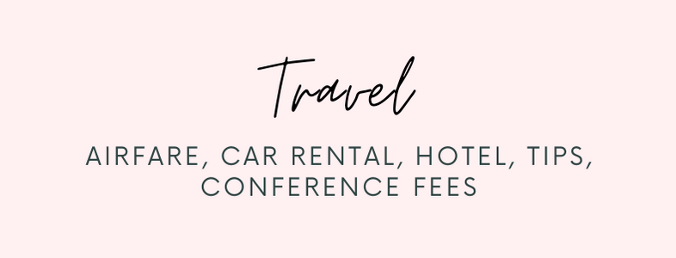 |  |  |  | emily franks  independent sales director  5665 lower 182nd st west  farmington minnesota  55024
 |  | 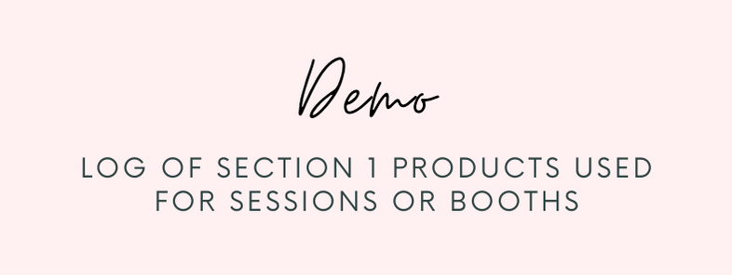 |  |  |  | emily franks  independent sales director  5665 lower 182nd st west  farmington minnesota  55024

